Design Decisions for a 3D Scene — 7-1 Final Project
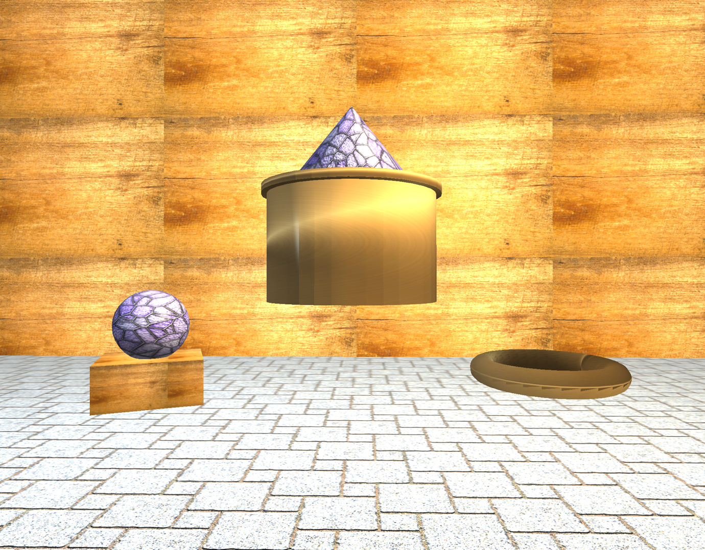
In this project, I assembled the final 3D scene in OpenGL based on the solutions I had gradually developed in previous milestone tasks. My goal was not to create a photorealistic world, but to build a neat and clear composition using simple shapes that demonstrates mastery of the basic tools of computer graphics, including geometry, lighting, and projections. For the scene, I selected several objects that differ significantly in shape and material — as shown in the screenshot above, a composite object assembled from cylinders and a pyramid is located in the center. Next to it are a ball on a stand and a ring on the floor. The scene is further defined by the floor and the back wall. This approach was convenient because it allowed me to use several basic primitives from the assignment list, and at the same time, the same set of simple shapes made it possible to assemble both individual objects and a more complex object. In computer graphics, a complex model is often built not as a single massive shape, but as a combination of simpler parts. For example, a cylinder on its own is just a simple shape, but if you add another cylinder and a pyramid to it, you already get a fully-fledged composite object with a top, a base, and a decorative part, as in my case.
When building the scene, I tried to keep the geometry fairly simple. The point of the low-polygon approach is to avoid overloading the scene with unnecessary polygons where a simpler solution will suffice visually. This makes it easier to control the object’s shape, debug the code, and monitor how light and textures interact with the surface. In other words, a good scene is not always one with the maximum amount of detail. Often, a logical structure and neat assembly are more important.
I used textures to give the objects the appearance of distinct surfaces and shadows, rather than monochromatic blanks. The floor uses a tile texture, the wall a wood grain, the central metal object a gold texture, and some decorative elements a more expressive scaly pattern. Texture in projects like these helps quickly convey the material without creating complex geometry. For example, the floor could have been modeled from numerous individual tiles, but that would have greatly complicated the scene. It makes much more sense to use a single plane and apply a high-quality texture with UV scaling to it. This essentially saves resources and time, but I believe it still produces a visually compelling result.
Lighting was one of the most important parts of the project, and I set up multiple light sources to prevent objects from appearing flat or completely shadowed. The scene features a general directional light and two-point lights, one of which provides a warmer tone, while the other acts as a cooler fill light. This was done intentionally, as using only one light could make parts of the scene appear too unreadable. By adding the second light, the shapes of the objects become more clearly visible. This is particularly noticeable on the cylinders and the sphere, where the lighting reveals volume through the transitions between light and shadowed areas. The project also uses components of the Bougainville model. To put it simply, ambient is the general soft light, diffuse shows how light falls on a surface, and specular is responsible for highlights. It is precisely because of specular reflection that a metallic surface looks shinier than a matte one.
I designed the scene navigation so that the user can freely examine the objects. The WASD keys control movement forward, backward, left, and right, while Q and E control movement up and down. The camera rotates with the mouse, and the mouse wheel adjusts the movement speed. This control scheme is convenient because it is similar to controls in 3D applications and games. I also implemented a switch between perspective and orthographic projections: perspective mode makes the scene more natural to the eye, and orthographic mode removes this effect and presents the scene in a more technical manner. This is useful because one mode is better suited for visual perception, while the other is better for assessing the shape and placement of objects.
To keep the code organized, I divided it into several parts. SceneManager is responsible for preparing the scene, textures, materials, lights, and rendering objects. ViewManager manages the camera, keys, mouse, and projection matrices. Separate functions like SetTransformations(), SetShaderTexture(), SetShaderMaterial(), and SetupSceneLights() help to avoid duplicating code. This makes the program cleaner and easier to extend. That said, if I wanted to add another object, I would not have to rewrite the entire scene — I could just use the existing structure. In general, I think that the final scene successfully fulfills the requirements of the task: it contains several low-polygon objects, uses textures, lighting, interactive camera, and different types of projection. At the same time, the code remains quite clear and logically organized, which is as important as the visual result.

